**Practical 13:**

**Program to stimulate water tank:**

**Code:**

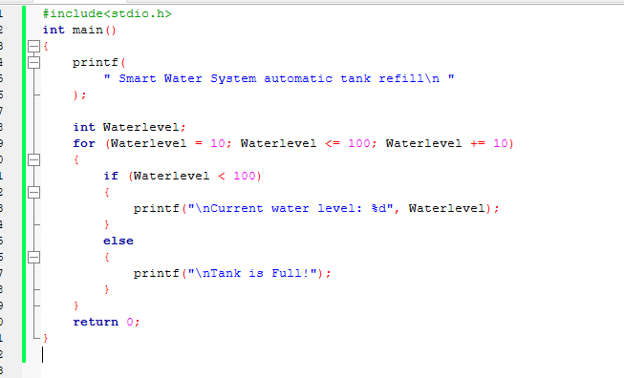

**Output:**

